**Diff Between VM and Docker:**

* **Docker Containers are light weight alternatives of Vms**
* **Docker Containers don’t have OS they use Host OS**
* **No need to pre-allocate ram it takes ram accordingly**
* **Very less run time.no need to boot os**

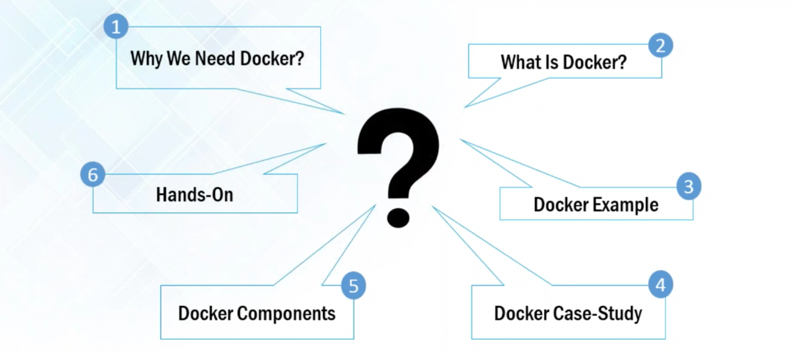

**Problems before docker:**

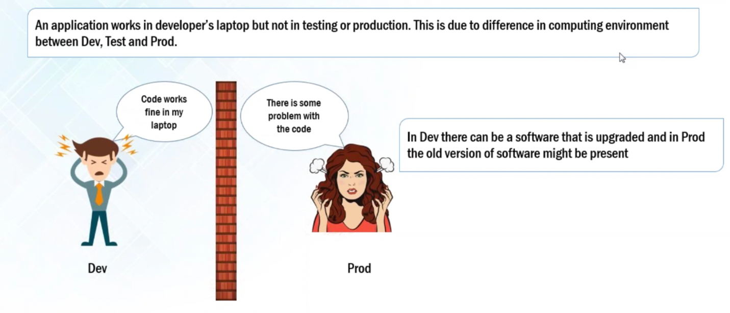

**Why Docker:**

**1)**Some type of applications are easy to build and maintain when they are broken as mini services.

**2)** We can update services separately then it will not affect whole application.

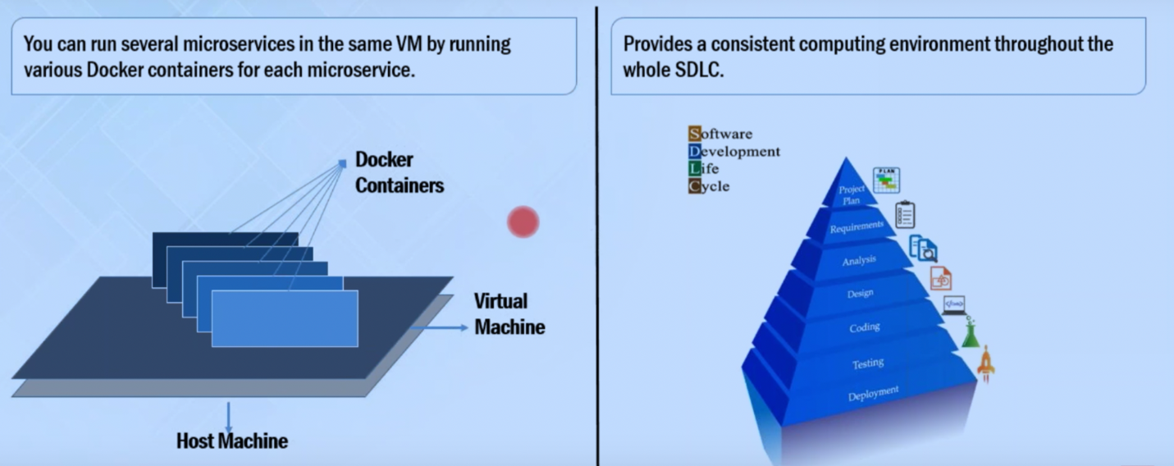

**What is Docker:**

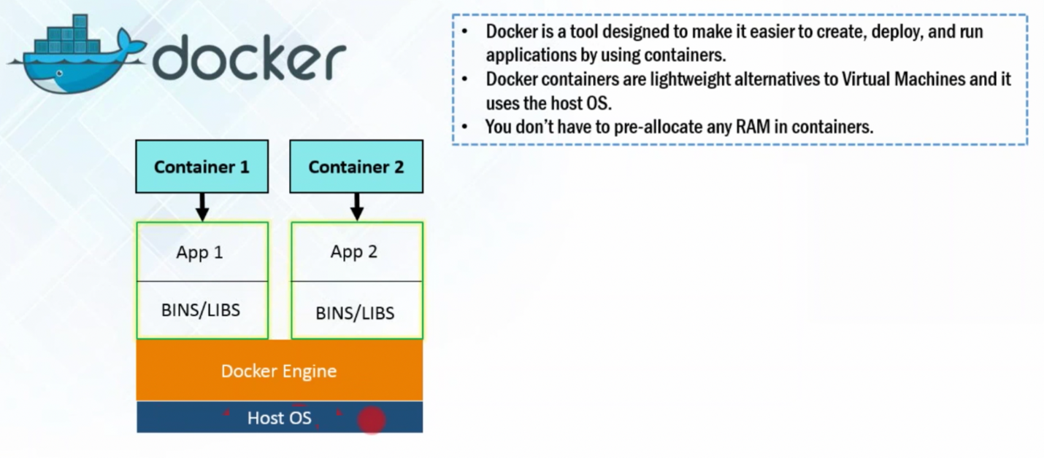

**Host os (linux) >> Docker Engine >> Containers >> app & bin,lib**

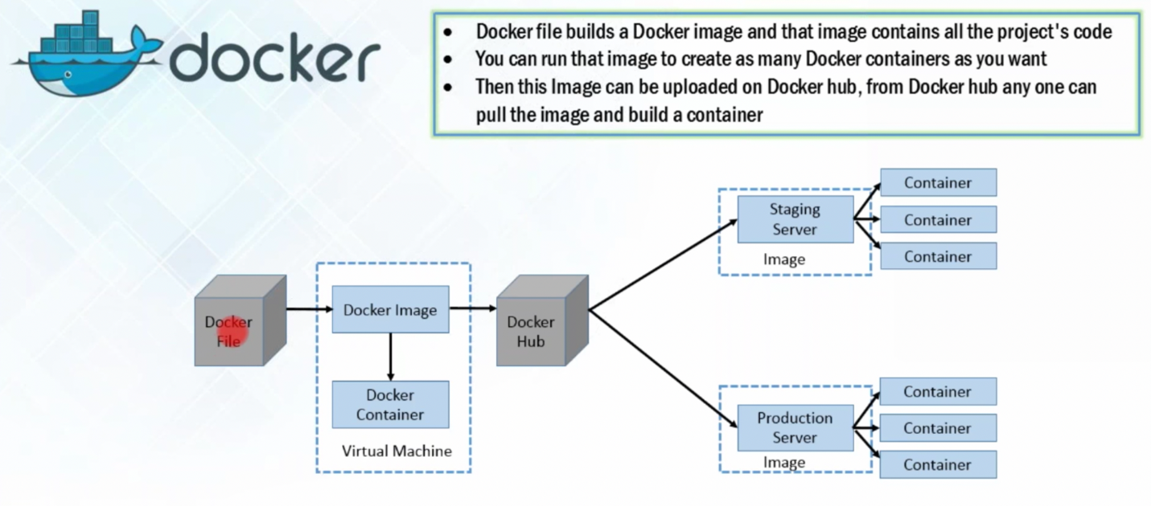

**Docker Containers are run time instance of Docker image**

**>> Docker Hub is git repo of Docker Images**

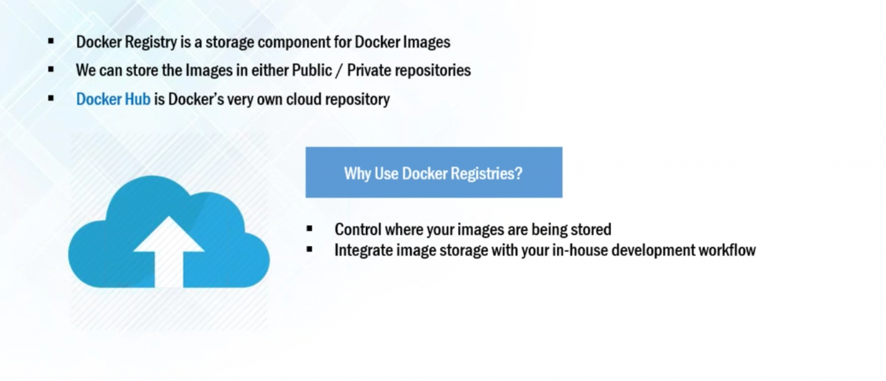

**Docker Image:**

**Contains code or app devloped by devlopers**



**Docker Containers:**

**run time instances of Docker images. Container can be one or more images**

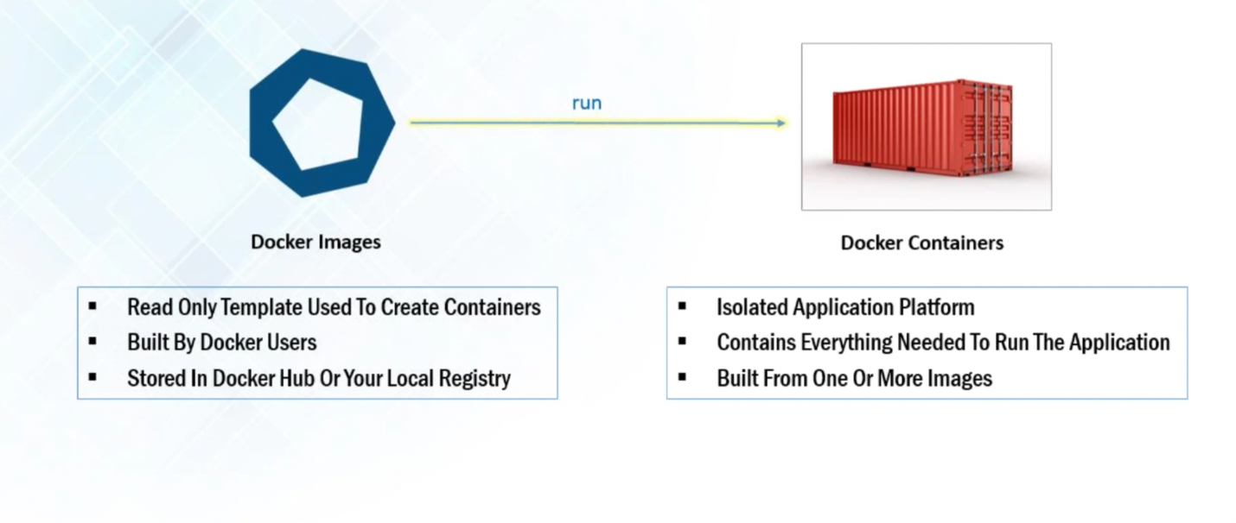

Docker Compose:

